**GIT – Barcelona – Madrid – Sevilla – Lisbon – 8 nights**

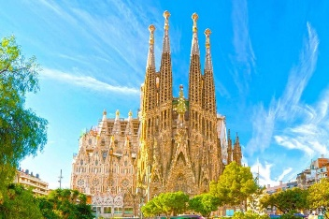 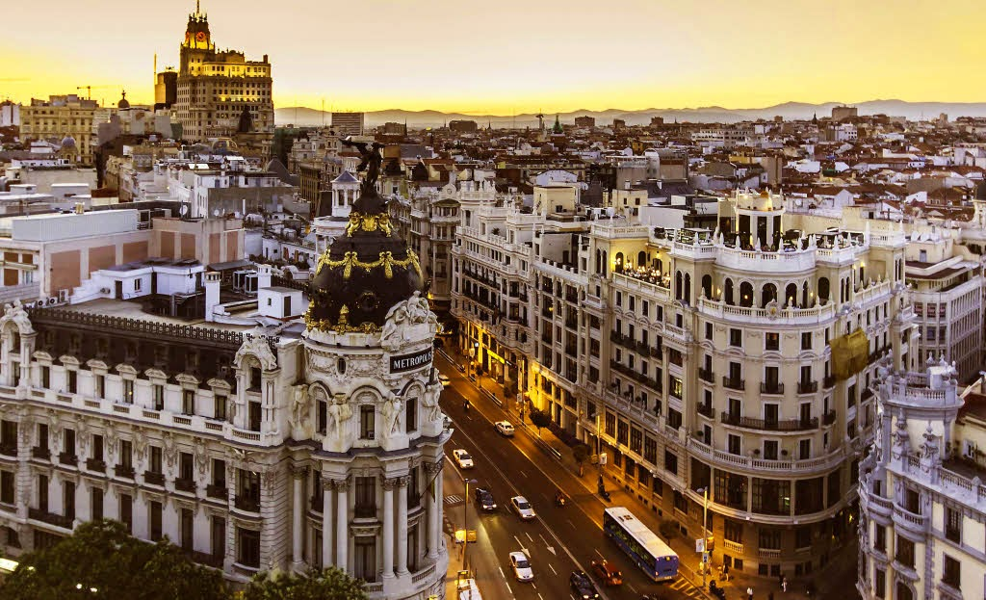 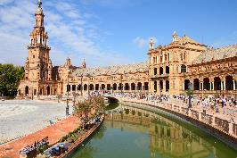 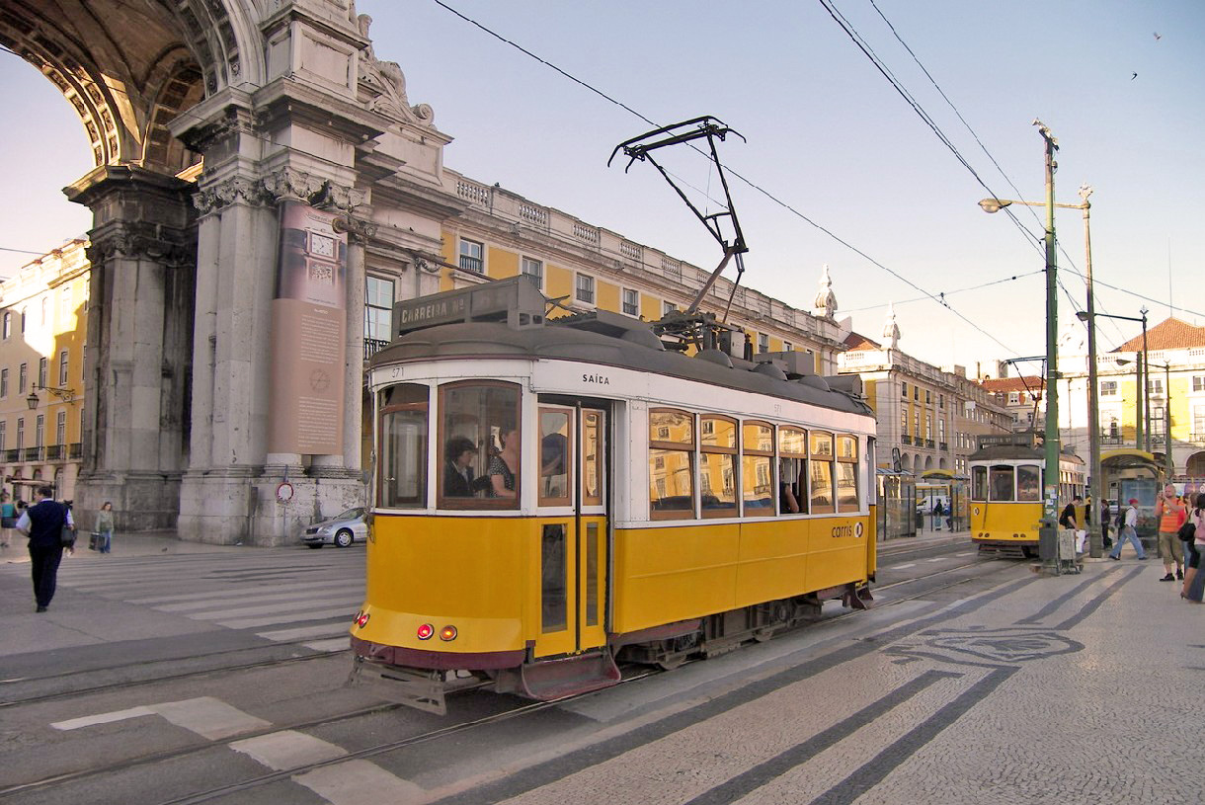

**day 1 Barcelona**

English speaking assistance upon arrival at airport.   
**private transfer** from Barcelona airport to the hotel in Barcelona.

half day **Barcelona sightseeing** on private basis.

*enjoy Barcelona, discovering the most interesting places from the artistic and cultural point of view:* ***the Gothic Cathedral, Plaça Catalunya, Passeig de Gràcia, Sagrada Familia…***

overnight at hotel in Barcelona.

**day 2 Barcelona**

breakfast at the hotel.

half day **Montserrat excursion** on private basis.

*Montserrat, an imposing rocky outcrop, is the holy mountain of Catalonia, which houses the revered image of the Black Virgin.*

overnight at hotel in Barcelona.

**day 3 Barcelona – Zaragoza - Madrid**

breakfast at the hotel and check out.

**private transfer** from Barcelona to Madrid. brief stop in Zaragoza en route to admire the impressive basilica.

afternoon at leisure to explore the city on your own.

overnight at hotel in Madrid.

**day 4 Madrid**

breakfast at the hotel.

half day **Madrid sightseeing** on private basis.

*this half-day visit offers a complete tour of the history and architecture of the city of Madrid:* ***Puerta de Alcalá, Cibeles, Puerta del Sol, Plaza de la Villa, Plaza Mayor****, Carrera de San Jerónimo, Calle Atocha, Reina Sofia Museum, Atocha main railway station, Ministry of Agriculture,* ***Prado Museum****, Banco de España, Paseo de* ***la Castellana, Bernabeu football stadium****.*

overnight at hotel in Madrid.

**day 5 Madrid**

breakfast at the hotel.

half day **excursion to Toledo** on private basis.

***Toledo*** *is one of the Spanish cities with the greatest heritage of monuments. known as the “city of the three cultures”, Toledo preserves behind its walls an artistic and cultural legacy in the form of churches, palaces, fortresses, mosques and synagogues.*

overnight at hotel in Madrid.

**day 6 Madrid - Sevilla**

breakfast at the hotel and check out.

**private transfer** from *Madrid to Sevilla*.

half day **Sevilla sightseeing** on private basis.

*the tour starts at* ***the Isla de la Cartuja*** *which was chosen as the site for the expo’92. the* ***Plaza de España*** *and adjoining* ***Maria Luisa Park*** *are among the most pleasant and impressive public spaces in Spain. the tour continues in* ***Santa Cruz Quarters*** *with its narrow white alleys, flowered patios and wrought ironed balconies. inside visit of the cathedral of Saint Mary of the See.*

overnight at hotel in Sevilla.

**day 7 Sevilla - Lisbon**

breakfast at the hotel and check out.

**private transfer** from Sevilla to Lisbon.

half day **Lisbon sightseeing** on private basis.

*drive through one of the main avenues of the city, till* ***Rossio square*** *– heart of the city. the tour continues with a little walk in* ***Alfama****, the oldest and the most picturesque quarter of the city. you will also see the* ***famous Belem Tower*** *and the* ***Monastery of Los Jerónimos****.*

overnight at hotel in Lisbon.

**day 8 Lisbon**

breakfast at the hotel.

full day **Sintra & Cascais** **excursion** on private basis.

***Sintra*** *is located 30 km from Lisbon. in 1995 the town of Sintra was classified as a world heritage site, with architectural monuments that stand out such as the* ***Town Palace****,* ***the Pena Palace*** *with inside visit and the* ***Moorish Castle****.* ***Cascais*** *is a former fishing village situated in the southern region of Portugal, where visitors can enjoy its* ***picturesque architecture****. return to Lisbon along the coast, passing by Estoril, admiring the beautiful coast and its beaches.*

overnight at hotel in Lisbon.

**day 9 Lisbon**

breakfast at the hotel and check out.

**private transfer** from hotel to Lisbon airport.

**end of services**

**prices**

**81**

|  |  |  |  |  |  |  |
| --- | --- | --- | --- | --- | --- | --- |
| **package price per person** | **Nov - Mar** | | **Apr - Oct** | | **Jul - Aug** | |
| **standard class**  **\*hotels in Barcelona and Madrid located in outskirts** | **pax** | **€** | **pax** | **€** | **pax** | **€** |
| **15-19** | 767 | **15-19** | 855 | **15-19** | 819 |
| **20-24** | 650 | **20-24** | 735 | **20-24** | 700 |
| **25-29** | 580 | **25-29** | 663 | **25-29** | 629 |
| **30-39** | 542 | **30-39** | 624 | **30-39** | 590 |
| **40-49** | 481 | **40-49** | 562 | **40-49** | 528 |
| **single suppl.** | **223€** | | **257 €** | | **256 €** | |
| **half board suppl.** | **136 €** | | | | | |
| **first class *hotel in Barcelona located in outskirts** | **pax** | **€** | **pax** | **€** | **pax** | **€** |
| **15-19** | 819 | **15-19** | 944 | **15-19** | 864 |
| **20-24** | 700 | **20-24** | 820 | **20-24** | 745 |
| **25-29** | 629 | **25-29** | 745 | **25-29** | 671 |
| **30-39** | 590 | **30-39** | 704 | **30-39** | 631 |
| **40-49** | 528 | **40-49** | 639 | **40-49** | 569 |
| **single suppl.** | **251 €** | | **328 €** | | **277 €** | |
| **half board suppl.** | **176 €** | | | | | |
| **superior class *hotel in Barcelona located in outskirts** | **pax** | **€** | **pax** | **€** | **pax** | **€** |
| **15-19** | 990 | **15-19** | 1.221 | **15-19** | 1.075 |
| **20-24** | 863 | **20-24** | 1.086 | **20-24** | 945 |
| **25-29** | 787 | **25-29** | 1.005 | **25-29** | 968 |
| **30-39** | 745 | **30-39** | 959 | **30-39** | 824 |
| **40-49** | 680 | **40-49** | 889 | **40-49** | 757 |
| **single suppl.** | **377 €** | | **507 €** | | **436 €** | |
| **half board suppl.** | **213 €** | | | | | |

* prices per person based on double room & bb basis. minimum 15 pax, maximum 49 pax.

* one person in single room free of charge.

* prices subject to availability and possible fluctuations in any of the requested services at the time of final booking.

**validity**: **until October 2020.**

**inclusions:**

|  |  |  |  |  |
| --- | --- | --- | --- | --- |
| **city & nights** | **private transfers** | **sightseeing on private basis** | **meals** | **24h phone assistance** |
| **2n Barcelona** | **by coach** | half day city tour  half day Montserrat excursion | breakfast |
| **3n Madrid** | half day city tour  half day Toledo excursion |
| **1n Sevilla** | half day city tour *including entrance fee to cathedral* |
| **2n Lisbon** | half day city tour  full day Sintra & Cascais excursion *including entrance fee of Pena palace* |

* one person free of charge.

**prices do not include:**

* regional tourist tax.
* tips and guests´ extras.
* any other service not mentioned on the programme / itinerary described.

**itinerary & number of nights**

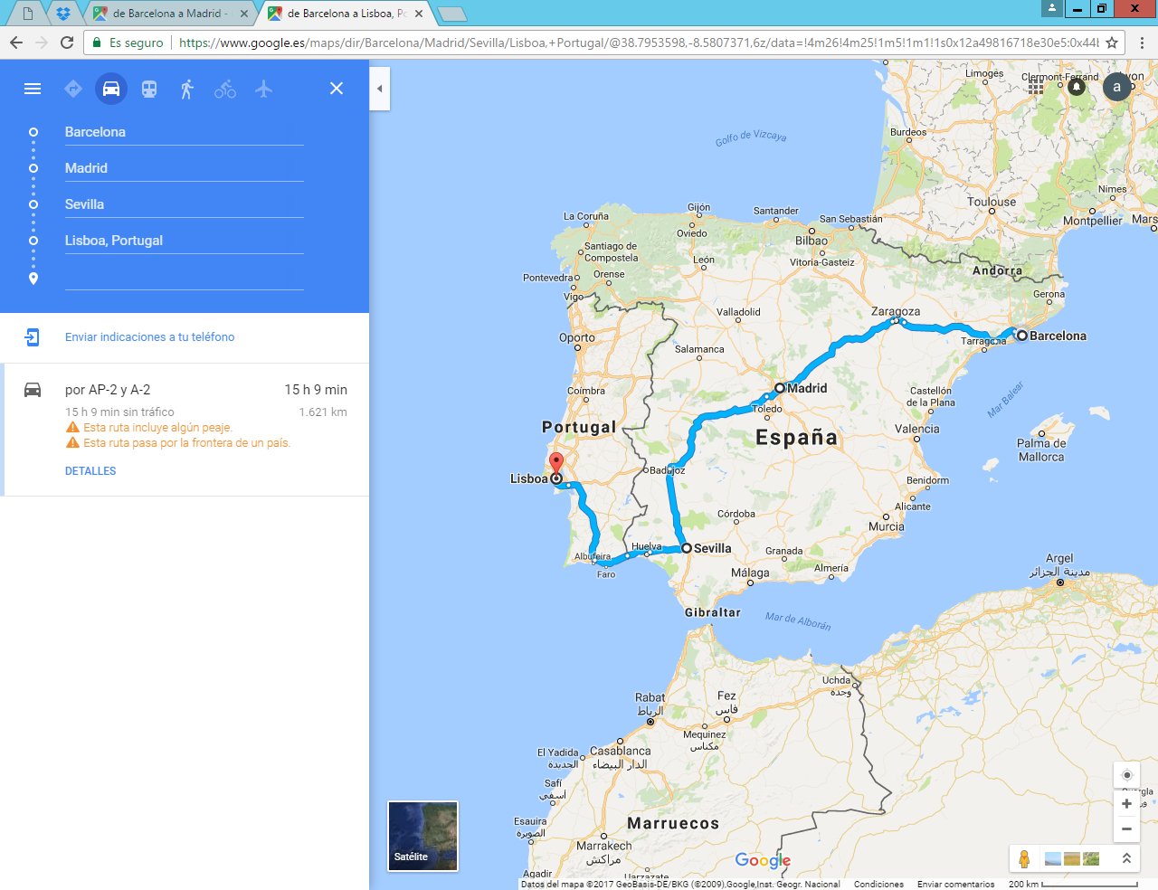

**2n**

**Barcelona**

**1n**

**Sevilla**

**3n**

**Madrid**

**2n**

**Lisbon**

